2205 Victoria Ave. Regina, SK S4P 0S4

CRIMINAL RECORD CHECK REQUEST LETTER

To whom it may concern:

This letter serves to introduce you to ____________________________________ whom is a Volunteer Coach/Manager/Trainer with the _____________________________________ team, which/whom are members of the Saskatchewan Broomball Association, a Non-Profit Organization as of September 1st, _______.

The Canadian Broomball Association along with the Saskatchewan Broomball Association require criminal record checks (specifically including vulnerable youth sector) of all individuals involved with coaching minor players under the age of 19. Our volunteer coaches, managers, trainers are in close contact with children aged 5-18, supervising in dressing rooms, coaching on and off the ice, transporting players to practices or games. These individuals are in a position of trust and/or authority.

These individuals are not paid for any services and with that we understand your usual fee will be waived as this is for a non-profit organization.

Sincerely,

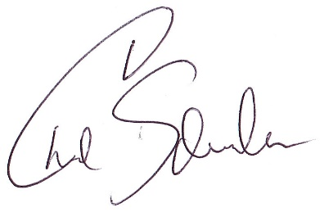

Chad Schneider President
Saskatchewan Broomball Association

